Employee Name | K RENGAPRASAD
Employee ID no. | WRK-011477
Review Period | 1 January 2025 –  31 December 2025 | Review Date
Reviewed by: | SUNIL RNVA

- REVIEWING GOALS ACHIEVEMENTS 2025

  - Capture and evaluate your goals for 2025

NOTE: In case of more goals, please copy and paste a new table. We recommend not creating more than 10 goals.

GOAL #1
Goal Name
1. Increase Test Coverage
2. Reduce Defect Escape Rate
Goal Description
Increase Test Coverage
• Specific: Enhance test coverage by writing more test cases for critical application features to ensure comprehensive validation.
• Measurable: Increase test coverage from 50% to 70% for critical application features within the next 12 months.
• Achievable: Collaborate with the development and product teams to identify high-risk areas and focus on creating test cases for those features.
• Relevant: Better test coverage leads to identifying more defects early, ensuring higher quality and fewer post-release issues.
• Time-bound: Achieve 70% test coverage for critical features within the next 12 months.
SMART Goal Example: "Increase test coverage for critical application features to 70% within the next 12 months by writing additional test cases."
Reduce Defect Escape Rate
• Specific: Minimize the number of defects that escape into production by improving testing rigor and defect identification.
• Measurable: Reduce the defect escape rate from 15% to 5% over the next 12 months.
• Achievable: Focus on enhancing test case design, conducting more regression tests, and ensuring better defect tracking and reporting.
• Relevant: Reducing defects that escape to production improves product quality and customer satisfaction.
• Time-bound: Achieve a 5% defect escape rate within the next 12 months.
SMART Goal Example: "Reduce the defect escape rate to 5% within the next 12 months by enhancing test case coverage and regression testing."
Due Date
12/31/2025
Employee Evaluation
Add here
Manager Evaluation
Add here
GOAL #2
Goal Name
3. Improve Test Case Quality
4. Speed Up Test Execution Time
5. Implementation of AI based Test case generation for Functional and Impact Test cases , as applicable
Goal Description
Improve Test Case Quality
• Specific: Enhance the quality of test cases by ensuring they cover edge cases and align with product requirements.
• Measurable: Achieve a 85% approval rate for test cases in review meetings over the next 12 months.
• Achievable: Review and refine test cases before submission, ensuring that they meet product requirements, cover all scenarios, and are easy to execute.
• Relevant: High-quality test cases reduce the number of bugs missed and improve the reliability of the testing process.
• Time-bound: Achieve a 85% approval rate for test cases in reviews over the next 12 months.
SMART Goal Example: "Achieve a 85% approval rate for test cases during review meetings within the next 12 months by improving their quality and coverage."
Speed Up Test Execution Time
• Specific: Reduce the time taken to execute manual and automated tests, contributing to faster release cycles.
• Measurable: Reduce test execution time by 20% within the next 12 months.
• Achievable: Streamline test execution by optimizing test case prioritization, reducing redundant tests, and improving the automation framework.
• Relevant: Faster test execution allows for quicker feedback on product quality and enables faster delivery.
• Time-bound: Achieve a 20% reduction in test execution time within the next 4 months.
SMART Goal Example: "Reduce test execution time by 20% within the next 12 months by optimizing test case prioritization and improving automation."
AI Based Tool
Generate Test cases through AI based tool for Functional and Impact area , as applicable
Due Date
12/31/2025
Employee Evaluation
Add here
Manager Evaluation
Add here
GOAL #3
Goal Name
6. Enhance Automation Skills
Goal Description
Enhance Automation Skills
• Specific: Improve automation skills to reduce manual testing efforts and speed up testing cycles.
• Measurable: Automate 30% of manual test cases for regression testing within the next 12 months.
• Achievable: Learn and apply automation tools (e.g., Selenium, Cypress) to create automated test scripts for repetitive test cases.
• Relevant: Automation improves testing efficiency and reduces human error, allowing for faster and more reliable test execution.
• Time-bound: Automate 30% of manual regression test cases within the next 12 months.
SMART Goal Example: "Automate 30% of manual regression test cases within the next 12 months using automation tools like Selenium or Cypress."
Due Date
12/31/2025
Employee Evaluation
Add here
Manager Evaluation
Add here
GOAL #4
Goal Name
7. Enhance Collaboration with Development Team
Goal Description
Enhance Collaboration with Development Team
• Specific: Improve communication and collaboration with the development team to resolve issues quickly and ensure alignment on testing.
• Measurable: Participate in at least 3 sprint planning or backlog grooming sessions per month for the next 12 months.
• Achievable: Engage with developers early to understand new features, clarify requirements, and identify potential testing challenges.
• Relevant: Closer collaboration between testers and developers ensures a better understanding of requirements, reduces defects, and speeds up testing.
• Time-bound: Attend 3 sprint planning or backlog grooming sessions per month for the next 3 months.
SMART Goal Example: "Participate in at least 3 sprint planning or backlog grooming sessions per month for the next 12 months to improve collaboration with the development team."
Due Date
12/31/2025
Employee Evaluation
Add here
Manager Evaluation
Add here
GOAL #5
Goal Name
8. Track and Report Testing Metrics
Goal Description
Track and Report Testing Metrics
• Specific: Improve the tracking and reporting of testing metrics to better understand the effectiveness of testing and identify areas for improvement.
• Measurable: Create weekly reports on key testing metrics such as defect density, test pass rates, and test coverage for the next 12 months.
• Achievable: Use testing tools and project management software to track metrics and create reports on test progress and quality.
• Relevant: Reporting on testing metrics helps identify trends, measure testing effectiveness, and inform decisions on process improvements.
• Time-bound: Provide weekly testing reports for the next 12 months.
SMART Goal Example: "Create and present weekly reports on key testing metrics such as defect density and test pass rates for the next 12 months."
Due Date
12/31/2025
Employee Evaluation
Add here
Manager Evaluation
Add here

GOAL #6
Goal Name
9. Improve Test Data Management
Goal Description
Improve Test Data Management
• Specific: Improve the process of managing test data to ensure consistent and accurate testing conditions.
• Measurable: Establish a process for managing test data that reduces errors and improves test reliability by 25% over the next 12 months.
• Achievable: Work with the team to create reusable test data sets and automate data setup where possible.
• Relevant: Consistent test data ensures that tests are accurate and reliable, leading to better test results.
• Time-bound: Achieve a 25% improvement in test data management reliability within the next 12 months.
SMART Goal Example: "Establish a test data management process that improves reliability by 25% over the next 12 months by creating reusable test data sets."

Due Date
12/31/2025
Employee Evaluation
Add here
Manager Evaluation
Add here
GOAL #7

Goal Name
10. Increase Participation in Test Planning
Goal Description
Specific: Become more involved in the test planning process by contributing ideas and feedback during the planning phase.
• Measurable: Contribute at least 3 suggestions or improvements to the test plan during each sprint's planning phase for the next 12 months.
• Achievable: Review requirements early, participate in planning meetings, and provide input on test coverage, strategies, and test cases.
• Relevant: Being actively involved in the planning process ensures that testing is aligned with development goals and the product vision.
• Time-bound: Provide 3 suggestions or improvements to the test plan during each sprint's planning phase for the next 12 months.
SMART Goal Example: "Contribute 3 suggestions or improvements to the test plan during each sprint's planning phase for the next 12 months."
Due Date
12/31/2025
Employee Evaluation
Add here
Manager Evaluation
Add here
OUR CORE VALUES & BEHAVIOURS

Our Core Values should provide a consistent standard by which performance is evaluated. Please provide your evaluation on each of the values in the sections below. You should be able to demonstrate that you have embraced the values through the achievement of your goals.
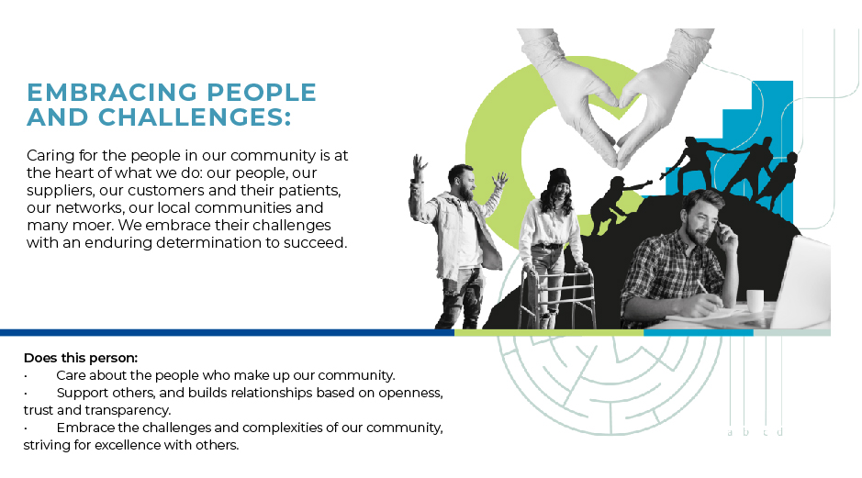

Please capture here your comments
Employee:
Building strong and effective relationships with peers while proactively fostering a positive and collaborative team environment.
Establishing a safe and inclusive space for regular discussions to drive continuous improvement in processes and enhance the overall work environment.
Promoting open communication and supporting colleague communities to strengthen engagement, collaboration, and mutual support.

Manager
Add here

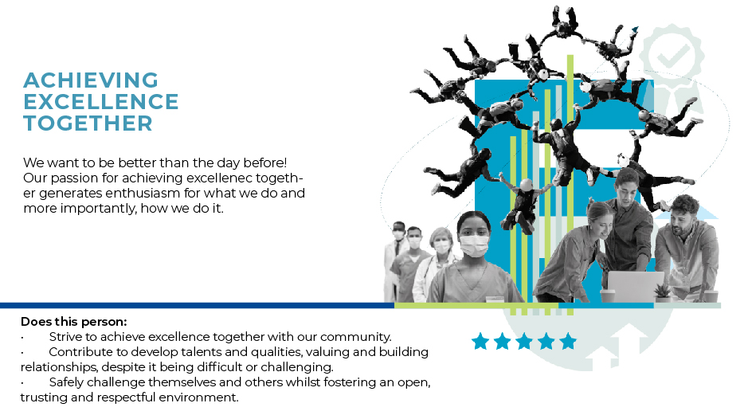

Please capture here your comments
Employee:
Add here

Manager
Add here

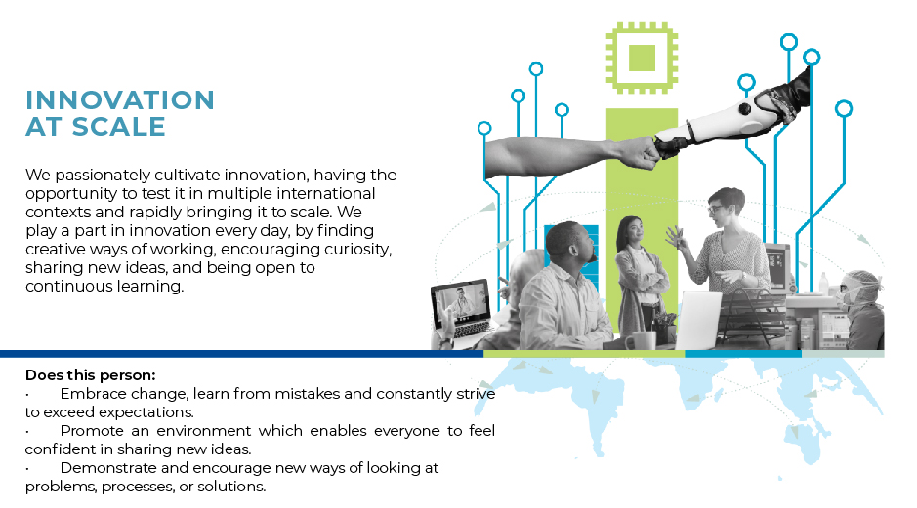

Please capture here your comments
Employee:
Add here
Manager
Add here

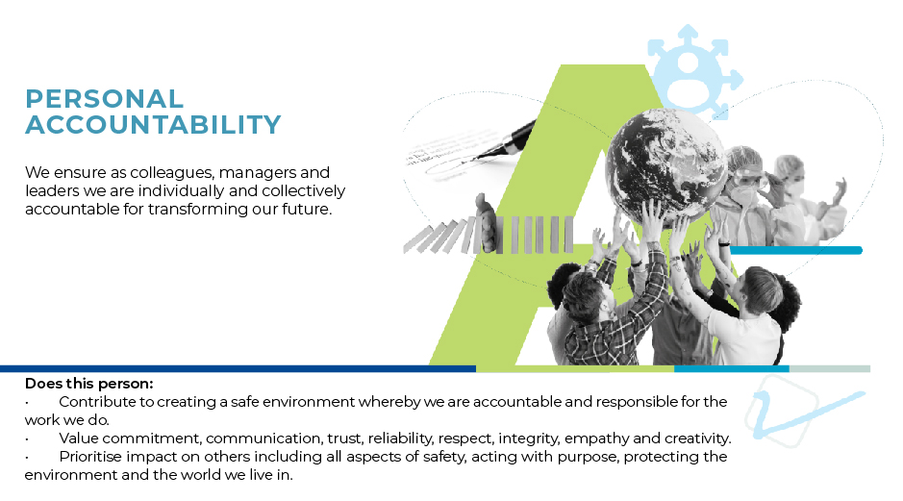

Please capture here your comments
Employee:
Add here

Manager
Add here



Please capture here your comments
Employee:
Add here

Manager
Add here

- DEVELOPMENT PRIORITIES

Please now consider any development priorities based on performance but also career aspirations and capture them in this area.

Please capture here your comments
Employee:
Add here

Manager
Add here

- OVERALL PERFORMANCE EVALUATION

Now that you have evaluated the “what” and the “how”, please use the space below to give an overall evaluation. Reminder: We are no longer providing an overall performance rating, so it is important that you clearly articulate your feedback.

Please capture here your comments
Employee:
Add here

Manager
Add here

